Step 1: Log into Infinite Campus
Step 2: Click Index
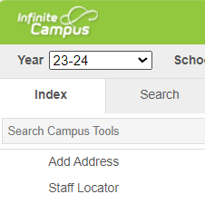

Step 3: Click on Ad Hoc Reporting
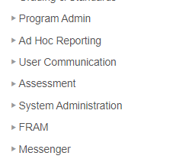

Step 4: Click Filter Designer
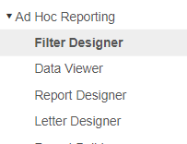
Step 5: Open Ad Hoc ES Secretary for elementary secretaries or Ad Hoc Registrars for high school and middle school registrars. Select student Directory Information/School Media.
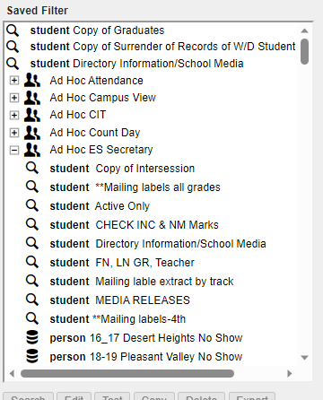
Step 3: Select Edit
Step 4: Next
Step 5: Select “N” for Feilds 8. customPerson.School/Media and 9. customPerson.RestrictDirectoryInfo.
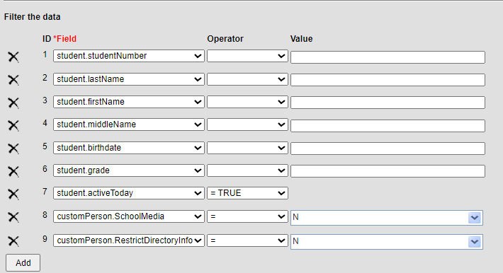
Step 6: Select Save & Test. This will produce your list of students who selected “No” to directory information and school media during OLR.

